CS-340
Brennen Lawson
Project Two: README File

Grazioso Salvare Rescue Animal Dashboard

About the Project
This project was created for Grazioso Salvare, an international rescue-animal training company. Grazioso Salvare identifies dogs that may be strong candidates for search-and-rescue training. These dogs can help locate and rescue humans or animals in dangerous situations, including water rescue, wilderness rescue, disaster response, and human tracking.
The dashboard uses Austin Animal Center outcome data stored in MongoDB. It allows users to view, filter, and visualize animal records through an interactive web dashboard. The goal of this project is to help Grazioso Salvare quickly identify dogs that match specific rescue-training profiles.

Required Functionality
The dashboard includes the required functionality requested by Grazioso Salvare. It includes the Grazioso Salvare logo, a unique identifier with my name, interactive rescue-type filters, a dynamic data table, a breed distribution chart, and a geolocation map.
The dashboard includes four filter options: Water Rescue, Mountain or Wilderness Rescue, Disaster or Individual Tracking, and Reset. When a user selects one of the rescue filters, the dashboard queries the MongoDB database and updates the data table, breed distribution chart, and geolocation map. The Reset option returns the dashboard to the original unfiltered view.
The Water Rescue filter displays dogs that match Grazioso Salvare’s preferred water rescue profile. This includes dogs that are Labrador Retriever Mix, Chesapeake Bay Retriever, or Newfoundland breeds, are intact female, and are between 26 and 156 weeks old.
The Mountain or Wilderness Rescue filter displays dogs that match the mountain or wilderness rescue profile. This includes dogs that are German Shepherd, Alaskan Malamute, Old English Sheepdog, Siberian Husky, or Rottweiler breeds, are intact male, and are between 26 and 156 weeks old.
The Disaster or Individual Tracking filter displays dogs that match the disaster or tracking rescue profile. This includes dogs that are Doberman Pinscher, German Shepherd, Golden Retriever, Bloodhound, or Rottweiler breeds, are intact male, and are between 20 and 300 weeks old.

Screenshots
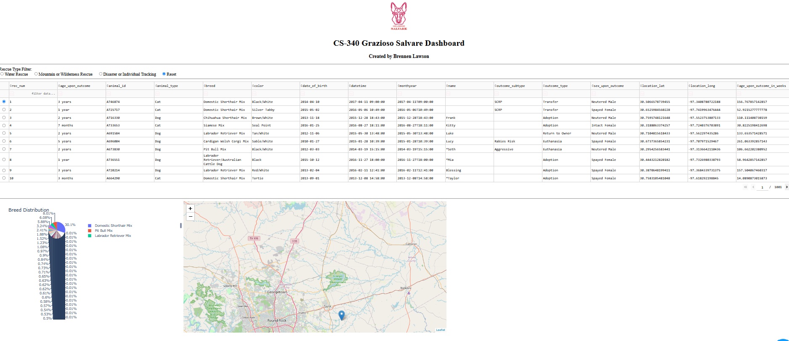
Reset Filter Screenshot:
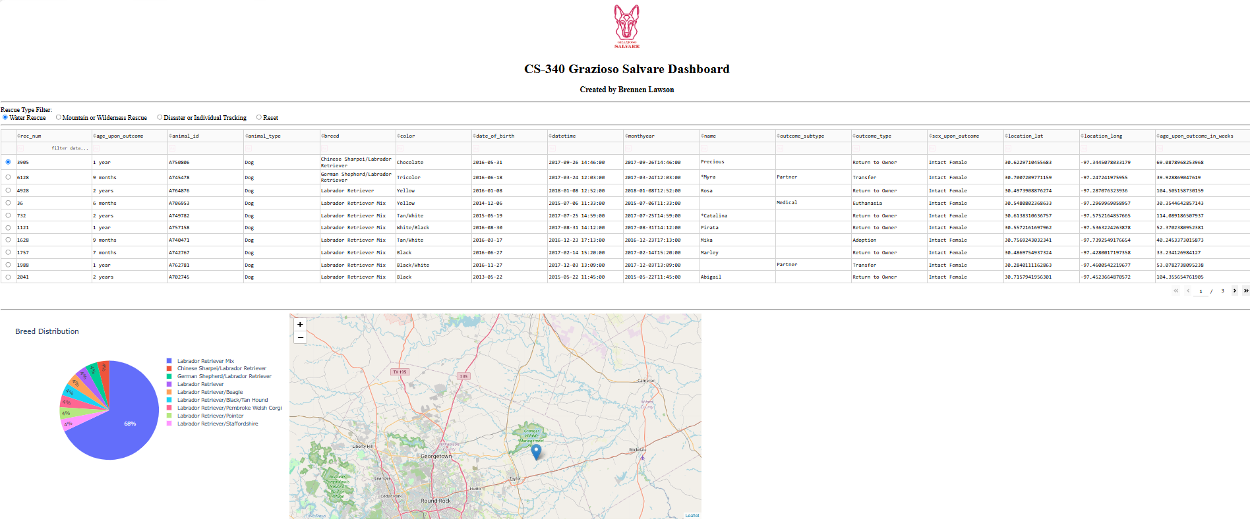
Water Rescue Filter Screenshot:
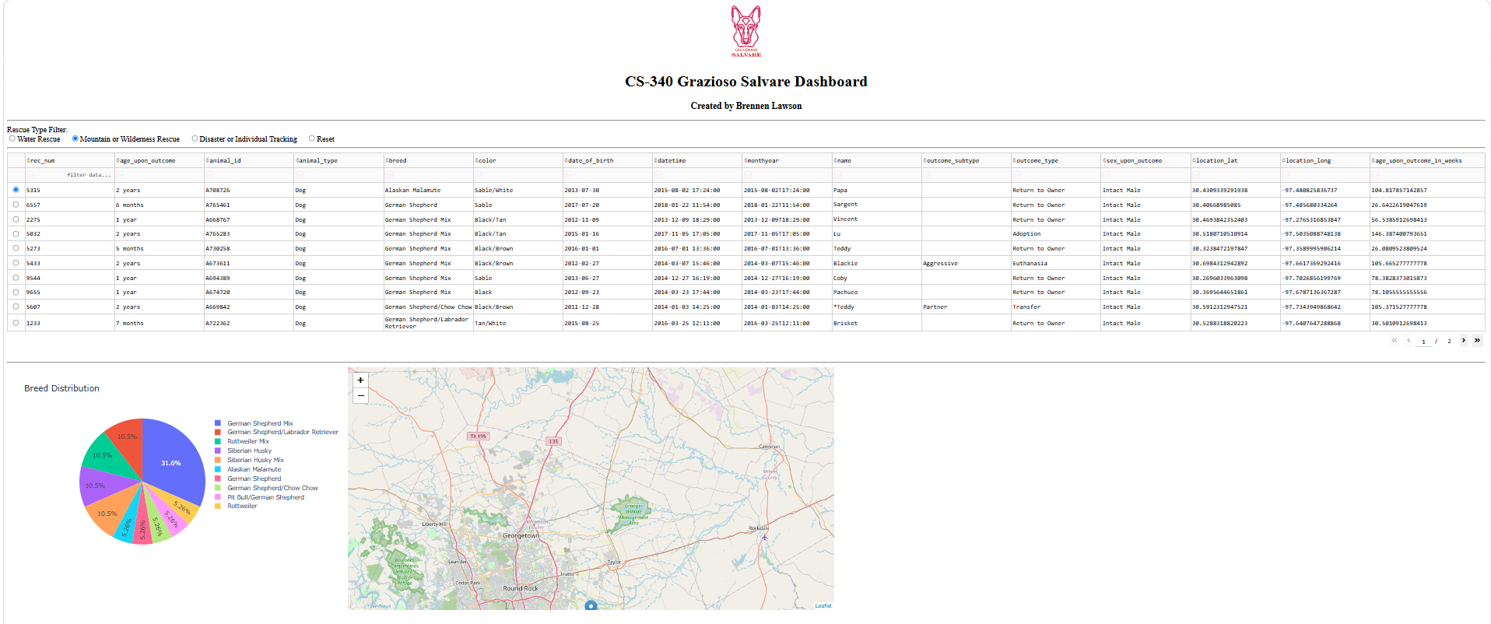
Mountain or Wilderness Rescue Filter Screenshot:
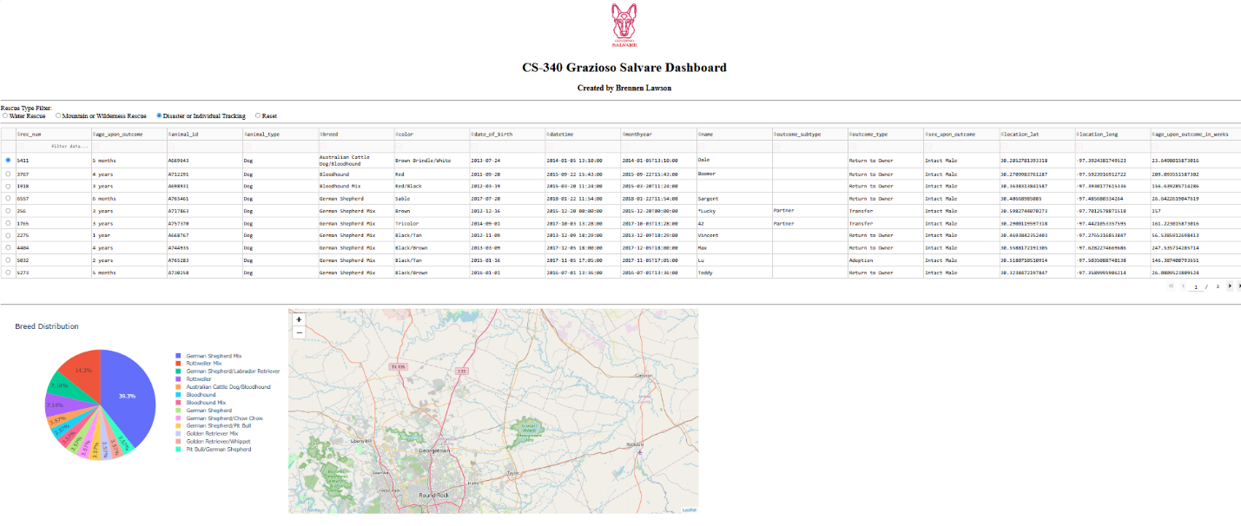
Disaster or Individual Tracking Filter Screenshot:

Tools Used
Python was used as the primary programming language for the dashboard and CRUD module. The Jupyter Notebook file and the CRUD module are both written in Python. Python was chosen because it is readable, widely used, and works well with data processing, database connections, and web dashboard libraries.
MongoDB was used as the database for storing the Austin Animal Center animal outcome records. MongoDB works well for this project because it stores data as flexible JSON-like documents. This is useful for animal shelter records because each animal can be stored as a document with fields such as animal type, breed, age, sex, location, and outcome information.
PyMongo was used to connect the Python CRUD module to MongoDB. PyMongo allows the Python code to send queries to the MongoDB database and return the results to the dashboard. In this project, the CRUD module acts as the model component because it handles database access and retrieves the animal records.
Dash was used to build the interactive web dashboard. Dash provides the view and controller structure for the web application. The dashboard layout, including the logo, filters, data table, chart, and map, represents the view. The callback functions act as the controller because they respond to user selections, run database queries, and update the dashboard widgets.
JupyterDash was used to run the Dash application inside Jupyter Notebook. This made it possible to develop, test, and display the dashboard directly in the notebook environment.
Pandas was used to convert MongoDB query results into DataFrames. This made the data easier to display in the Dash data table and easier to use for the chart and map widgets.
Dash DataTable was used to display the animal records in an interactive table. The table supports filtering, sorting, pagination, and single-row selection.
Dash Leaflet was used to create the geolocation map. The map displays the location of the selected animal record based on the latitude and longitude data in the table.
Plotly Express was used to create the breed distribution chart. This chart updates based on the filtered data and helps the user quickly understand which breeds appear in the current results.
Codio and Jupyter Notebook were used as the development and testing environment for the project.

Resources
Dash Documentation: https://dash.plotly.com/

Dash DataTable Documentation: https://dash.plotly.com/datatable

Dash Leaflet Documentation: https://www.dash-leaflet.com/

Plotly Express Documentation: https://plotly.com/python/plotly-express/

Steps Taken to Complete the Project
First, the Austin Animal Center outcomes dataset was imported into MongoDB. The database was named aac, and the collection was named animals. A MongoDB user account named aacuser was used to access the database.
Next, a Python CRUD module was created to provide reusable database functionality. This module connects to MongoDB and allows the dashboard to retrieve records from the animals collection. The dashboard imports the AnimalShelter class from the CRUD module and uses it to query the database.
After the database connection was working, the ProjectTwoDashboard Jupyter Notebook was updated. The notebook was configured to import the required Python libraries, including Dash, JupyterDash, Pandas, Plotly Express, Dash DataTable, Dash Leaflet, and the CRUD module.
The dashboard layout was then customized to include the Grazioso Salvare logo, a unique identifier with my name, filter options, a data table, a breed distribution chart, and a geolocation map.
Next, interactive filter options were added for Water Rescue, Mountain or Wilderness Rescue, Disaster or Individual Tracking, and Reset. These filters were connected to MongoDB queries that matched the rescue dog profiles provided in the Dashboard Specifications Document.
The data table was configured to update when a filter was selected. The table was also given user-friendly features such as pagination, sorting, filtering, horizontal scrolling, and single-row selection.
A breed distribution chart was added using Plotly Express. This chart updates based on the currently filtered data in the table.
A geolocation map was added using Dash Leaflet. This map updates based on the selected row in the table and displays the location of the selected animal record.
Finally, I tested the dashboard by running the notebook and selecting each filter option. I took screenshots to show that the Reset, Water Rescue, Mountain or Wilderness Rescue, and Disaster or Individual Tracking filters all update the dashboard widgets correctly.

Challenges and Solutions
One challenge for me was choosing a second chart that would be useful to the client. The dashboard already had a table and a map, so the second chart needed to summarize the filtered data in a way that helped the user quickly understand the results. I solved this by creating a breed distribution pie chart, which shows which breeds appear most often in the selected rescue category.
Another challenge I had was translating the rescue dog requirements into working database queries. The Dashboard Specifications Document listed preferred breeds, sex, and age ranges for each rescue type, but those requirements had to be converted into MongoDB query logic. I solved this by writing a separate query for each rescue type using the correct breed patterns, sex value, and age range.

